**Output of Running Chapter 9 source code:**

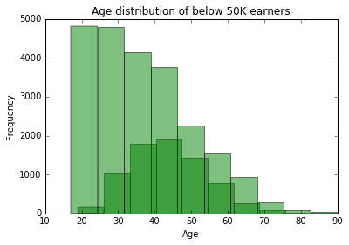

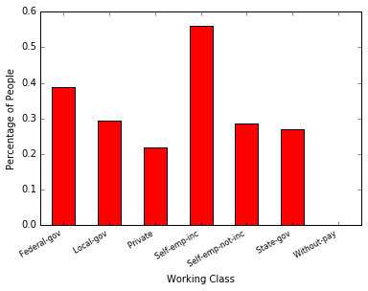

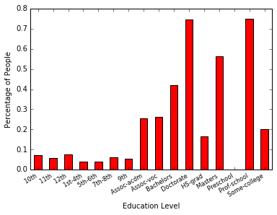

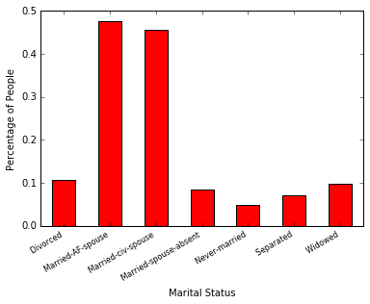

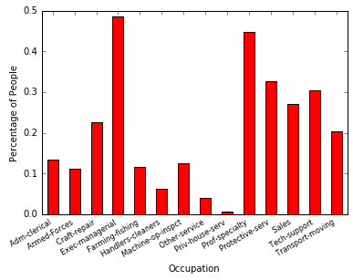

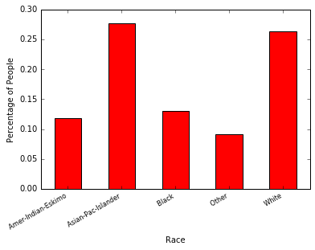

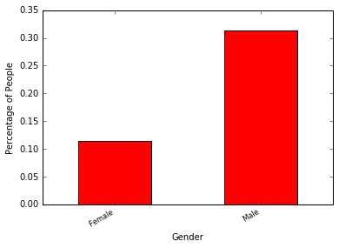

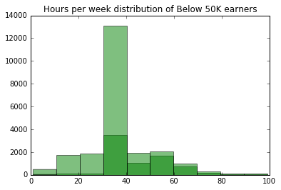

Predicted 0.0 1.0

Actual

0.0 9849 1511

1.0 1772 1928

precision recall f1-score support

0.0 0.85 0.87 0.86 11360

1.0 0.56 0.52 0.54 3700

avg / total 0.78 0.78 0.78 15060

Predicted 0.0 1.0

Actual

0.0 10138 1222

1.0 1682 2018

precision recall f1-score support

0.0 0.86 0.89 0.87 11360

1.0 0.62 0.55 0.58 3700

avg / total 0.80 0.81 0.80 15060

Predicted 0.0 1.0

Actual

0.0 10280 1080

1.0 1642 2058

precision recall f1-score support

0.0 0.86 0.90 0.88 11360

1.0 0.66 0.56 0.60 3700

avg / total 0.81 0.82 0.81 15060

Predicted 0.0 1.0

Actual

0.0 10483 877

1.0 1641 2059

precision recall f1-score support

0.0 0.86 0.92 0.89 11360

1.0 0.70 0.56 0.62 3700

avg / total 0.82 0.83 0.83 15060

